

Fairhill Medical
Practice

www.fairhill.gpsurgery.net

Partners

Dr Elizabeth Katay Dr Sarah Foddy Dr Nellie Gupta Dr Greg Maylen Dr Richard Van Mellaerts


Fairfield and Kingston Hill Branch

University Branch

Clinical Staff
Doctors
Partner: Dr Elizabeth Katay (F)  MD (Semmelweis, Hungary 1985); LMSSA, London 1989; diploma obstetrics (1990, Auckland, NZ); FP.Cert 1992; MRCGP 1993 | Is Senior partner of the Practice. She works at the Kingston Hill site and is trained in the fitting and removal of contraceptive implants and IUDs.
Partner: Dr Sarah Foddy (F)  MB BS (London 1987) MRCGP DRCOG DFFP | Works at the Fairfield site and has a special interest in Dermatology.
Partner: Dr Nellie Gupta (F)  MB BS (New Delhi 1978) FRCS; FRCOG; DFFP | She is able to insert and remove IUCD's and implants. She also does regular Ante-natal, Post-natal and well women checks. She also has a keen interest in diabetes and oversees our Diabetic Patients with our nursing staff.
Partner: Dr Richard Van Mellaerts (M)  MSc MB BS (London 2000) MRCGP, DRCOG | Joined the Practice in 2010 and works at the Kingston Hill site. He has an interest in Men's health, Urology and Mental Health. His Masters degree is in Primary Care.
Partner: Dr Greg Maylen (M)  MB BS(London 1998) MSc (Sports Medicine) MRCGP | Has a special interest in ENT, Surgery and especially in the treatment of Sports Injuries. Dr Maylen is also the registered Managing Partner of the Practice.
Dr Vaishali Nathan (F)  MB BS MRCGP MSc (Medical Management) | Has a special interest in Sexual Health and the Medical Management / Leadership of clinicians and is trained in Women & Child Health including all aspects of Family Planning.
Dr Amy Howarth (F)  MBBS (London 2001) BSc MRCGP DRCOG DFSRH | Has an interest in all aspects of Women's Health and is trained in the fitting and removal of contraceptive implants and IUDs.
Dr Polly Hodgkinson (F)  MB BS DFFP MRCGP | Dr Hodgkinson joined the practice in 2014 but has worked here before. She has an interest in Women and Child Health. She works at the Fairfield and University sites and is qualified to fit contraceptive implants.
Dr Melvin Kin (M)  MB BS MSc  Dr Rio Wimalasiri (F)  MB BS MRCGP | Dr Kin works at our Fairfield and Kingston Hill branches and has special interests in Women’s Health (MSc) and Musculoskeletal Medicine.  Dr Wimalasiri works at Fairfield and Kingston Hill branches. She speaks Russian and Sinhalese.
Dr Janine Burridge (F)  MB BS DFFP DRCOG | Has a special interest in Students Health, Sexual Health, Contraception and Diabetic Care in General Practice.
Nurses
Lead Nurse: Annette Derry (F)  RGN, BSc (Hons) | Manages our team of nurses. She has a special interest in diabetes and additional qualifications in family planning. She can also prescribe certain medications.
Louisa Greenaway (F)  RGN | Has various practice nurse experience, including Asthma and COPD, both in the NHS and privately.
Suzan Obranovic (F)  RGN | Has a special interest in Asthma and COPD in particular. She also has a community interpreter's certificate.
Luiza Bozdog (F)  RGN | Has a wide range of clinical skills including Vaccinations, Phlebotomy, Smears, Contraception and Travel.

Other Staff
Management
Business and Operations Manager:
John Griffin

Fairfield Branch Manager:
Parvin Mawji

Kingston Hill Branch Manager:
Pat Jones

University Branch Manager:
Amanda Legg

Receptionist/Admin Staff
Fairfield | Kingston Hill |  | University
Deputy: Sue H | Deputy: Hayley |  | Deputy: Sue I
Michelle | Jane |  | Emilia T
Dil | Trisha |  | Trisha
Emilia R | Mehboob |  | Mel
Jean | Sara |  | Alicia
Charlotte | Patrice
Sharon | Sofia
 | Nadia
Support Staff
Data Administrator:
Angela

Medical Secretary:
Gina / Angela

Book keeper:
Pat

Community Support
Midwives |  | The midwife attends the Kingston Hill branch on alternate Wednesday mornings. Also they run clinics from Villiers Road in Kingston.
Dietitian |  | The dietitian runs a monthly clinic at the Kingston Hill and Fairfield Branches. Patients can be referred to the dietician by their GP.
District Nurses |  | We work with the district nurses at Acre Road. They visit housebound patients for blood tests, injections, dressings etc.

How to find us
Kingston Hill Branch
81 Kingston Hill
Kingston-Upon-Thames
Surrey
KT2 7PX

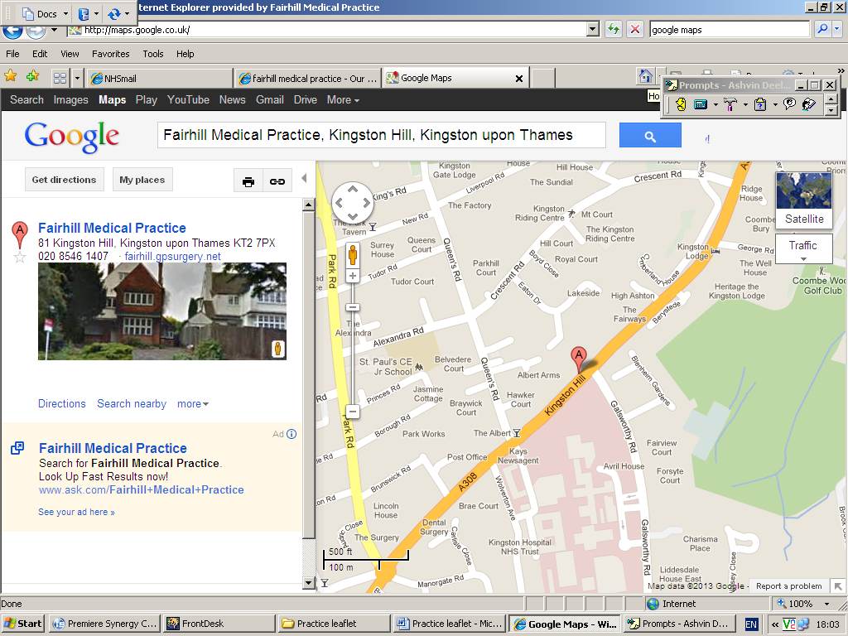

University Branch
Health Centre
Kingston University
Kingston-Upon-Thames
KT1 2EE

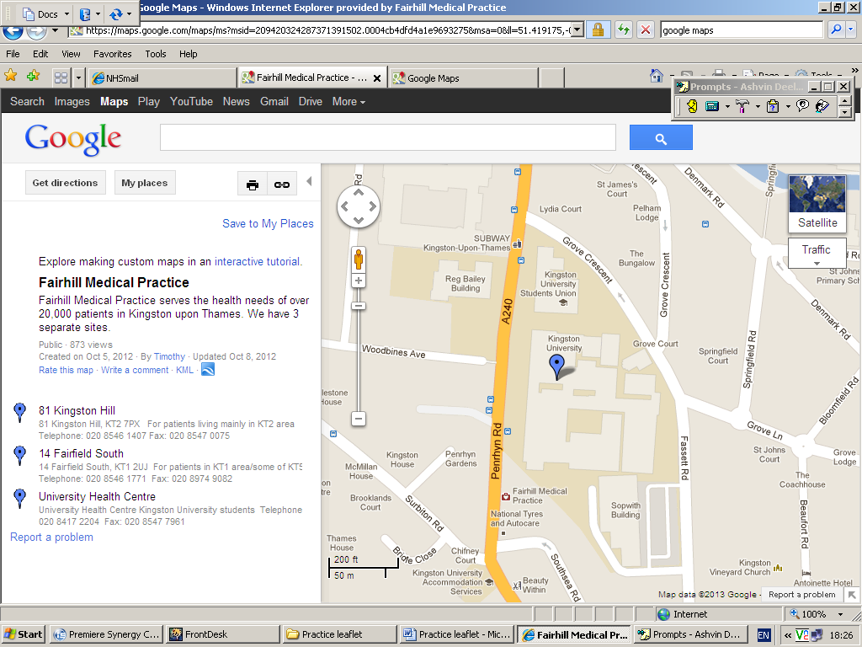

Other info and services

Patient feedback

We welcome your comments about the service you have received. Please write to us at the address provided. We undertake patient surveys and should you receive one of these we would be grateful if you could complete and return this to us.

Freedom of Information

The Freedom of Information Act 2000 obliges the practice to produce a publication Scheme. A Publication Scheme is a guide to the ‘classes’ of information the practice intends to routinely make available.

Fairfield Branch
14 Fairfield South
Kingston-Upon-Thames
Surrey
KT1 2UJ

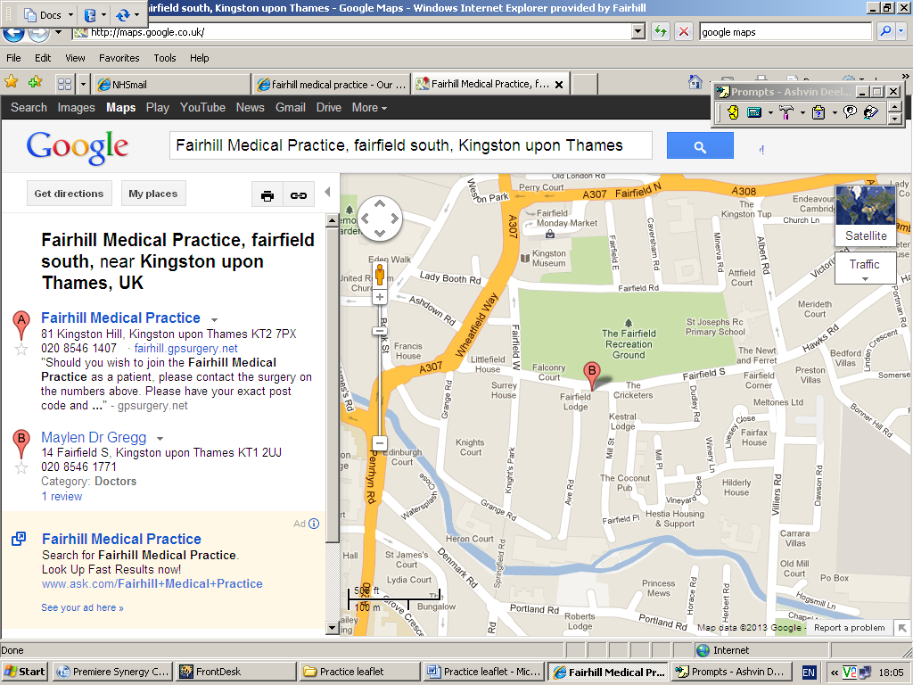

Patient Advice and Liaison Service (PALS)

If you need advice about health services in Kingston you can call the Kingston PALS team on 020 8546 7711. The PALS service is for patients, relatives, carers and friends who need somewhere to turn to for on-the-spot help, advice and support. PALS acts as a central point from where information can be obtained.

Complaints

Whilst every effort is made to provide high quality services to you, if you wish to make a complaint please contact the branch manager where you are registered at the address provided.

Kingston Hill Branch

81 Kingston Hill
Kingston-Upon-Thames
Surrey
KT2 7PX

Tel: 0208 546 1407
Fax: 0208 547 0075
Fairfield Branch

14 Fairfield South
Kingston-Upon-Thames
Surrey
KT1 2UJ

Tel: 0208 546 1771
Fax: 0208 974 9082

Branch Opening times
 | Kingston Hill Branch | Fairfield South Branch
Monday | 8.00am – 6.30pm | 8.00am – 6.30pm
Tuesday | 8.00am – 6.30pm | 8.00am – 6.30pm
Wednesday | 8.00am – 6.30pm | 8.00am – 6.30pm
Thursday | 8.00am – 6.30pm | 8.00am – 6.30pm
Friday | 8.00am – 6.30pm | 8.00am – 6.30pm
Saturdays (Alternate) | 8.30am – 11.00am | 8.30am – 11.00am

Fairfield and Kingston Hill Branch

Kingston Hill and Fairfield Branches

About Fairhill Medical Practice

Fairhill Medical Practice serves the health needs of over 20,000 patients in Kingston upon Thames. We have 3 separate branches: Kingston Hill, Fairfield and University. The Kingston Hill and Fairfield branches are open from 8.00am - 6.30pm Monday to Friday and also run appointments most evenings to 8.00pm and on alternate Saturday mornings.

The practice is registered with the Care Quality Commission. Our registration certificate number is: CRT1-593680496
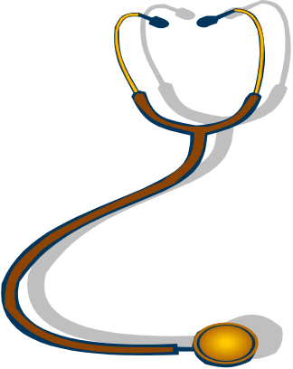
New Patients

All new patients registering with Fairhill Medical Practice are required to complete a registration form, available to collect from reception or print off the website, and provide proof of identity and proof of address. Once completed please hand to a member of staff at reception, where each new patient over 16 will be offered a simple Health Check which allows us to update your clinical records and start opportune health care.

Booking Appointments

Following a recent patient survey we have updated our appointment system to accommodate as many patient needs as possible. All appointments with doctors are standard 10 minute appointments - should you wish to book a longer appointment, please enquire at reception. We try to make sure you see the doctor of your choice but if they are not available we may ask you to see another doctor. All appointments are for one patient only; separate appointments must be booked for each patient.

Pre-Booking
There is an average of 24 appointments available every day which can be booked up to 6 weeks in advance.

Booking on the day
Approximately 50% of appointments are released on the day; this is an average of 20 for the morning and 12 for the afternoon. To book an appointment on the day patients are required to contact the surgery via telephone or in person at the specified times. (If coming into the surgery we advise arriving 5 minutes before they are released to avoid disappointment)

The ‘book on the day’ morning appointments are released at 8am

The ‘book on the day’ afternoon appointments are released at 2pm

Home Visits

If you are disabled or too ill to come to the surgery and feel you require a visit at home, please call the surgery before 10.30am. Home visits take up much more of a doctor’s time than a consultation in the surgery, so if you are mobile please come into the surgery to be seen.

Telephone consultations

The doctors do not currently conduct telephone consultations however simple messages can be left with reception and will be given to the next available doctor.


Outside Surgery Hours

If you need to speak to a doctor outside surgery hours please call 111. For telephone advice only call NHS Direct on 0845 4647.

Alternatively visit a walk-in centre; our nearest centres are in Queen Marys Hospital, Roehampton or Teddington Memorial Hospital, Teddington.

Test Results

Please call the surgery between 12pm and 2pm for test results, our staff may not be able to help outside of these times as they will be dealing with other administration duties. Results normally take 1 week to come through to us, so please wait before phoning. We will only contact you, by phone or by post, if your results require further action.

Services

Repeat prescriptions

To request a repeat prescription, tick the items you need on the white page of your previous prescription form and either place in the secure repeat prescription box in the waiting area or post it to the surgery. To avoid errors, we are unable to take requests for repeat medications over the telephone. Your prescription will be ready for collection 48 hours later. If you prefer, we can post it back to you (you will need to provide a stamped addressed envelope).

Many pharmacies provide a service for ordering and collecting repeat prescriptions. Please speak to your pharmacy to see if they offer this service.

We are keen to ensure that patients with ongoing medical problems are monitored regularly. If you are due a medication review or require a blood test or blood pressure check you will be asked to make an appointment. Repeat prescriptions will not be routinely issued if patients do not attend these reviews.

Nursing

There are nursing clinics run from Monday to Friday at both branches. These are for routine dressings, blood tests, leg ulcer checks, blood pressure checks etc. Please ask at reception to see who will be the most appropriate healthcare professional to deal with your medical concern.

The nurses also run yearly chronic disease management reviews (for example COPD). Patients will be contacted to book their appointment. A nurse will review your condition and amend medication accordingly.


All asthmatic patients will be contacted to attend regular asthma checks. These are provided for general check-ups and advice from practice nurses on lifestyle, inhaler techniques and medication. These are undertaken during routine nursing appointments.


Travel clinic

Our nurses provide personalised travel consultations which include
all necessary vaccinations
and general travel advice.
These appointments take 20
minutes and should be booked at
least 4 weeks before you travel.

Fairhill Medical Practice is a registered yellow fever vaccination centre.

Diabetic clinic

We have a nurse who specialises in the care of diabetes and runs specific clinics for our diabetic patients. These provide advice on improving control and avoiding complications. All diabetics will be written to during the course of the year and advised to come in for their annual review with the practice nurse.

Dermatology clinic

Dr Foddy, one of the Partners at the Practice, has a special interest in dermatology. She runs fortnightly clinics at the Fairfield Branch. By providing this service many patients can obtain a more detailed opinion of their condition without waiting for an outpatient appointment at a hospital.

Patients registered at the Kingston Hill branch will need to be referred to this clinic by a GP.

Sports injury and ENT clinics

Dr Maylen at the Fairfield Branch has a special interest in both ENT and Musculoskeletal Medicine.

He can perform micro suction for ears and joint injections for sports injuries. If your GP thinks that these may be appropriate treatments for your condition they will refer you Dr Maylen for his opinion. Dr Maylen is also one of the Partners at the Practice.

Dietitian

Dietitian consultations provide a detailed look at diets, for those with concerns from chronic diseases such as Diabetes or those who require a general review due to high cholesterol etc. Patients will need to be referred to the dietitian by their GP.

Contraception

Contraceptive services are available on request. These include fitting and removal of a diaphragm (cap), IUD (coil), implant as well as injections and prescriptions for the Pill. For repeat prescriptions of the contraceptive pill please make an appointment with the nurse for a ‘Pill check’.
Cryotherapy

We have doctors specially trained in the use of cryosurgery. This involves using liquid nitrogen to freeze and remove benign skin lesions including warts and verrucas.

Maternity

Routine antenatal check-ups are performed by our qualified midwife. Antenatal care is shared between the doctor and the midwife. The midwife attends the Fairfield branch on alternate Thursday afternoons and the Kingston Hill branch on alternate Wednesday mornings.

On-Line Services

You can now register for on-line services. These include booking appointments and requesting repeat prescriptions. Please enquire at Reception.
Other information

Prams

A covered pram store is provided at both branches, it is situated at the side of the Kingston Hill branch and at the back of the Fairfield branch. Prams and pushchairs are not allowed inside the surgery building due to Health and Safety.

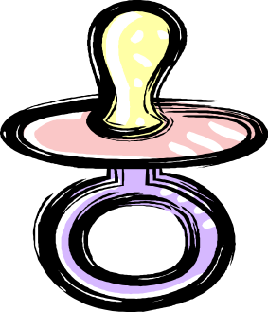
Baby and child immunisations

Our practice nurses carry out the childhood immunisation programme. Doctors carry out the new baby development check between 6-8 weeks of age.

Please contact the surgery to book your child’s vaccinations.

Seasonal vaccinations

We run a flu vaccination clinic in autumn. All patients aged over 65 are entitled to a free flu jab on the NHS as are patients under the age of 65 in certain "at risk groups".
Please ask at reception for further information.

All patients over the age of 65 are also invited to have a one off "pneumonia" vaccine, please ask the nurse for details.

Private fees

The NHS does not pay for some of the services we provide. These include private sick notes, insurance forms, holiday cancellation forms, medical reports, fitness to travel certificates, private prescriptions, and some vaccination services. The Fairhill Medical Practice fees for these services, which are in line with BMA approved national guidelines, are displayed in the surgery. Please ask at the reception should you require more information.

Parking

The surgery has very limited parking. You are requested NOT to drive unless it is essential. If you do park at the surgery please kindly DO NOT park in the GP allocated spaces.

University Branch

The Health Centre @ Kingston University
Penrhyn Road
KT1 2EE

Tel: 0208 417 2204
Fax: 0208 417 2961

Opening Times
Monday | 8.00am – 5.30pm
Tuesday | 8.00am – 5.30pm
Wednesday | 8.00am – 5.30pm
Thursday | 8.00am – 5.30pm
Friday | 8.00am – 5.30pm

University Branch

New Patients

All new patients registering with Fairhill Medical Practice are required to complete a registration form, available to collect from reception or print off the website. Once completed please hand to a member of staff at reception, where each new patient will be offered a simple Health Check which allows us to update your clinical records and start opportune health care.

Booking Appointments

Following a recent patient survey we have updated our appointment system to accommodate as many patient needs as possible. All appointments with doctors are standard 10 minute appointments - should you wish to book a longer appointment, please enquire at reception. We try to make sure you see the doctor of your choice but if they are not available we may ask you to see another doctor. All appointments are for one patient only; separate appointments must be booked for each patient.

Pre-Booking
There is an average of 24 appointments available every day which can be booked up to 6 weeks in advance.

During Holiday Times

The University branch is closed during the summer and term holidays. During these times the doctors at our other branches will see students. See their branch section for more details.

Please call:

Fairfield Branch 0208 546 1771

Kingston Hill Branch 0208 546 1407

Booking on the day
Approximately 50% of appointments are released on the day. To book an appointment on the day patients are required to contact the surgery via telephone or in person.

The ‘book on the day’ appointments are released at 8am

Telephone consultations

The doctors do not currently conduct telephone consultations however simple messages can be left with reception and will be given to the next available doctor.

Outside Surgery Hours

If you need to speak to a doctor outside surgery hours please call 111. For telephone advice only call NHS Direct on 0845 4647.

Alternatively visit a walk-in centre; our nearest centres are in Queen Marys Hospital, Roehampton or Teddington Memorial Hospital, Teddington.

Test Results

Please call the surgery between 12pm and 2pm for test results, our staff may not be able to help outside of these times as they will be dealing with other administration duties. Results normally take 1 week to come through to us, so please wait before phoning. We will only contact you, by phone or by post, if your results require further action.

Services

Contraception

Contraceptive services are available on request. These include fitting and removal of a diaphragm (cap), IUD (coil), implant as well as injections and prescriptions for the pill. The post coital pill should be taken within 72 hours of unprotected sex. (This is not a routine method of contraception) For repeat prescriptions of the contraceptive pill please make an appointment with the nurse for a ‘Pill check’.

Nursing

There are nursing clinics run from Monday to Friday at all branches. These are for routine dressings, blood tests, leg ulcer checks, blood pressure checks etc. Please ask at reception to see who will be the most appropriate healthcare professional to deal with your medical concern.

The nurses also run yearly chronic disease management reviews (for example COPD). Patients will be contacted to book their appointment. A nurse will review your condition and amend medication accordingly.

All asthmatic patients will be contacted to attend regular asthma checks. These are provided for general check-ups and advice from practice nurses on lifestyle, inhaler techniques and medication. These are undertaken during routine nursing appointments.

Travel clinic

Our nurses provide personalised travel consultations which include all necessary vaccinations and general travel advice. These appointments take 20 minutes and should be booked at least 4 weeks before you travel. Fairhill Medical Practice is a registered yellow fever vaccination centre.

Diabetic clinic

We have a nurse who specialises in the care of diabetes and runs specific clinics for our diabetic patients. These provide

advice on improving control and avoiding complications. All diabetics will be written to during the course of the year and advised to come in for their annual review with the practice nurse.

Dermatology clinic

Dr Foddy, one of the Partners at the Practice, has a special interest in dermatology. She runs fortnightly clinics at the Fairfield branch. By providing this service many patients can obtain a more detailed opinion of their condition without waiting for an outpatient appointment at a hospital.

Patients registered at the University branch will need to be referred to this clinic by a GP.

Sports injury and ENT clinics

Dr Maylen at the Fairfield Branch has a special interest in both ENT and Musculoskeletal Medicine. He can perform micro suction for ears and joint injections for sports injuries. If you’re GP thinks that these may be appropriate treatments for your condition they will refer you Dr Maylen for his opinion. Dr Maylen is also one of the Partners at the Practice.

Dietician

Dietician consultations provide a detailed look at diets, for those with concerns from chronic diseases such as Diabetes or those who require a general review due to high cholesterol etc. Patients will need to be referred to the dietician by their GP.

Cryotherapy

We have doctors specially trained in the use of cryosurgery. This involves using liquid nitrogen to freeze and remove benign skin lesions including warts and verrucas.

Repeat prescriptions

To request a repeat prescription, tick the items you need on the white page of your previous prescription form and either place in the secure repeat prescription box in the waiting area or post it to the surgery. To avoid errors, we are unable to take requests for repeat medications over the telephone. Your prescription will be ready for collection 48 hours later. If you prefer, we can post it back to you (you will need to provide a stamped, addressed envelope).Many pharmacies provide a service for ordering and collecting repeat prescriptions. Please speak to your pharmacy to see if they offer this service.

We are keen to ensure that patients with ongoing medical problems are monitored regularly. If you are due a medication review or require a blood test or blood pressure check you will be asked to make an appointment. Repeat prescriptions will not be routinely issued if patients do not attend these reviews.

On-Line Services

You can now register for on-line services. These include booking appointments and requesting repeat prescriptions. Please enquire at Reception.

Seasonal vaccinations

We run a flu jab clinic in autumn. All patients under the age of 65 in certain "at risk groups" are entitled to a free flu jab on the NHS as are patients. Please ask at reception for further information.

